
How to give yourself a subcutaneous injection

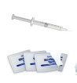
- Gather your supplies.
This includes your syringe (containing medicine) and an alcohol pad from your box.
- Wash your hands with soap and running water or hand sanitizer.
Dry well.
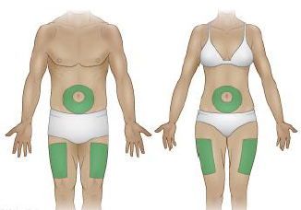
- Choose a spot on your belly or thigh for the shot (having side effects, choose your thigh).

A shot in the belly should be 5 centimeters
away from your belly button.

- Use alcohol to clean the skin.
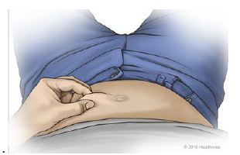
Let it dry.
- Remove the cap from the needle.
- Hold the syringe like a pencil close to the site.
Keep fingers off the plunger.
- Slightly pinch a fold of skin at the spot you choose.

Pinch it between your fingers and thumb of one hand.
- Place syringe at a 90-degree angle to the shot site
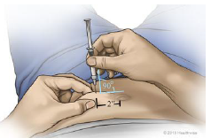
The needle should stand straight up from the skin.

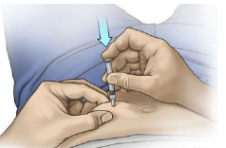

- Quickly push the needle all the way into the pinched-up fold of skin.

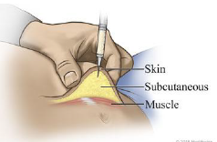
- Push the plunger of the syringe all the way in.

This allows the medicine to go into the fatty tissue. Be sure to hold the skin fold as you give the shot. This will help make sure you don’t inject the medication into muscle.

- Take the needle out at the same angle that you inserted it.
- Let go of the skin fold.
- If you bleed a little, apply pressure over the shot area.
You can use your finger, a cotton ball, or piece of tissue. To help avoid bruising do not rub area.
- Recap needle but becareful to not poke yourself. Put the used syringes back in your container that was given to you to bring back to the clinic to dispose of your needles.
- Slightly change the spot where you give the shot each time you do it.

If you have any questions or concerns, please don’t hesitate to contact the clinic.
You can either call/text to (715) 991.0882
Email at info@healthwellnessconnection.org
Facebook messenger

Clinic Hours: Tuesday-Friday
Tuesday Wednesday Thursday Friday
9am-4pm 10am-6pm 9am-4pm 9am-3pm

Health & Wellness Connection
3233A Business Park Dr. Suite 108
Stevens Point, WI 54482

